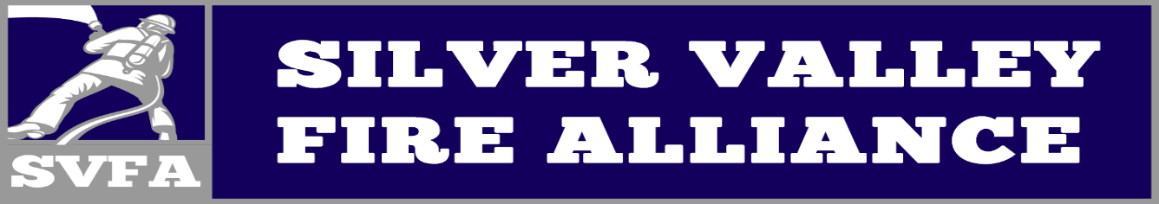
2022 First Tuesday Training outline
Date | Topic | Agency
January | Water tender operations | Newberry Springs
February | Radio Communications | CalFire
March | Wildland Fire fighting | Yermo/Calico
March 26th | Wildland Fire Drill (9a-1p) | Daggett Fire
April | Ground Ladders | Daggett Fire
May | RIC Training | Ft. Irwin Fire
June | Fire Behavior | Barstow Fire
June 25th&26th | Live Burn (9a-5p) | SVFA
July | ****Break**** | ****Break****
August | EMS Day | Desert Ambulance
September | Vehicle Extrication | MCLB
October | USAR Practices | SBCo Fire
October 29th | Rescue Drill (9a-1p) | SBCo Fire
November | LZ Night Operations | Mercy Air 66
December | 2023 Training Schedule | All Chiefs

Notes:
-Wildland Drill will be held behind Daggett Station 372 on 3/26 from 9a-1p
-Live Burn Exercise will be located @ SVHS on 6/25 & 6/26 all day. (pending trailer acquisition)
-Rescue Drill will be held @ Calico Ghost Town on 10/29

